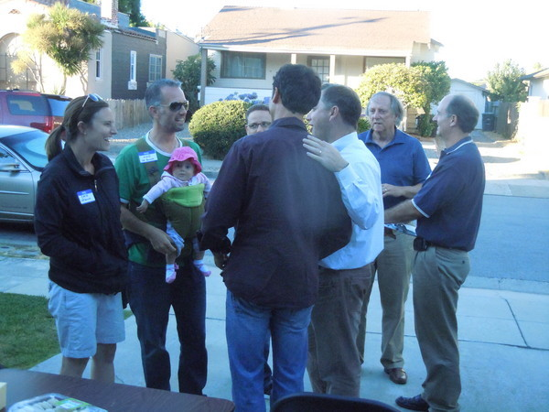

Your Street Here
National Night Out

Tuesday, August 5
6:00 - 7:00 p.m.
In front of [add address of home]
.
Join your name of street neighbors for this casual event, which is designed to help neighbors get acquainted and prevent crime. Burlingame Police officers may stop by. More info at https://natw.org.

We’ll provide wine, snacks and some chairs. If you’d like to bring a beverage or nibble to share, feel free! Children are welcome.

Your RSVP to fill in name and contact info would be appreciated, thank you.

