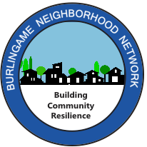

**(Your Street) Disaster Response Drill  
Saturday, October 5, 2024**

Dear Neighbor,

We’d like to invite you to be part of our **(*insert your street name*) Disaster Response Drill on** **Saturday, October 5,** from 9:00 to 10:30 a.m. at (***address where drill is to be held*)**. We will be one of numerous blocks participating in the Burlingame Neighborhood Network’s **Disaster Response Drill**, which will be supported by the **Central County Fire Department,** the **Burlingame Police Department, local CERTs** and **Ham radio operators.**

This drill offers a great opportunity to get to know your neighbors better and learn to help one another following a disaster, when emergency responders are not likely to be available to assist us for 72 hours or longer. During the drill, we will practice how we can respond as a neighborhood following a simulated, large earthquake. All neighbors are invited and no special training or knowledge is necessary. Adults and children aged 10 and older can take active roles in the drill. Feel free to bring younger children to observe.

If you’d like to participate, please let us know by emailing **(*your email address*) by Saturday, September 28**. If you’d like to take a leadership role in the drill, we’d love to have you join us; please let us know prior to **September 20.**

**Date: Saturday, October 5  
Time: 9:00-10:30 a.m.** *(Please arrive a few minutes early)* **Location: (Address where drill will be held)**

We hope you will join us in this important community exercise.

Thank you,

Your name

Your email and cell phone number