Poppy Drive 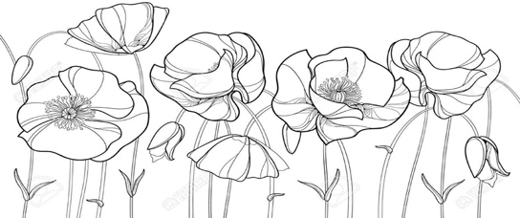 Invitation to Block Events

Dear Neighbor,

Now that we are emerging from pandemic restrictions, you are invited to these upcoming Poppy Drive events. Please add them to your calendars! If you’d like to join our organizing team for any of these activities, just email one of us (contacts below).

National Night Out
On Tuesday, August 3 from 5 to 6 p.m., Poppy is participating again in National Night Out, with a casual wine gathering in Richard and Jill’s front yard at 123 Poppy. Join us for a casual visit with your neighbors, bring a glass and we’ll have wine and snacks! This annual crime prevention event is co-sponsored by National Association of Town Watch and Burlingame Police Department. Neighbors are encouraged to turn on their outside lights until 9 p.m. and get to know one another, so they are more likely to notify each other if they spot something wrong.

Poppy Block Party
We thought it would be fun to have a Poppy Drive Block Party on Saturday, September 11, from 3 to 5 p.m. on the lower block of Poppy. Everyone is invited to bring your own food for the grill, sides and drinks. There will be fun activities for kids. Stay tuned for more party details.

Burlingame Disaster Survival Drill
Poppy Drive residents are planning to participate in the once-a-year citywide Disaster Response Drill on Saturday, October 9, from 9 to 10:30 a.m. This 90-minute exercise teaches neighbors how to help one another following a disaster, when emergency responders are unlikely to be available. We invite you to sign up by sending your name and street address to Holly or Terry. The drill is organized by the Burlingame Neighborhood Network, and will follow any current county health guidelines.

We look forward to seeing you soon!

Cathy Trower, ct@yahoo.com
Jack Martin, jmjmjm@gmail.com
Jennifer Crowson, jccc@jccc.com

