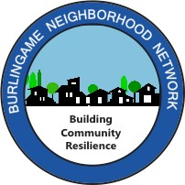

(insert your Block) Neighbors Disaster Response Drill Saturday,
October 8, 2022

Dear Neighbor,

We’d like to invite you to be part of our (insert your Block) Disaster Response Drill on Saturday, October 8 from 9:00 to 10:30 a.m. at (Address where drill is to be held).

We will be one of many blocks participating simultaneously, citywide, in this 90-minute Disaster Response Drill. The Drill is put on by Burlingame Neighborhood Network and is supported by the Central County Fire Department and the Burlingame Police Department.

This drill is a great opportunity to get to know your neighbors better and learn to help one another following a disaster. During the drill, we will practice how we can respond as a neighborhood following a simulated earthquake. All neighbors are invited, and no special training is necessary. Children 10-years and older can take active roles, and feel free to bring younger children to observe.

If you’d like to join in, please email us by Saturday, September 24. If you’re interested in taking a leadership role in the drill, please let us know!

Date: Saturday, October 8
Time: 9:00-10:30 a.m. (please arrive a few minutes early) Location: We’ll meet in the driveway of (Name)’s home, (Address)

Come out with your neighbors, have some fun with the hands-on drill, and learn how our block can respond to a disaster. We look forward to seeing you!

Thank you,

(Your name)
(Your email / phone)

